4K Measuring Storing Camera

BHDC-33TM
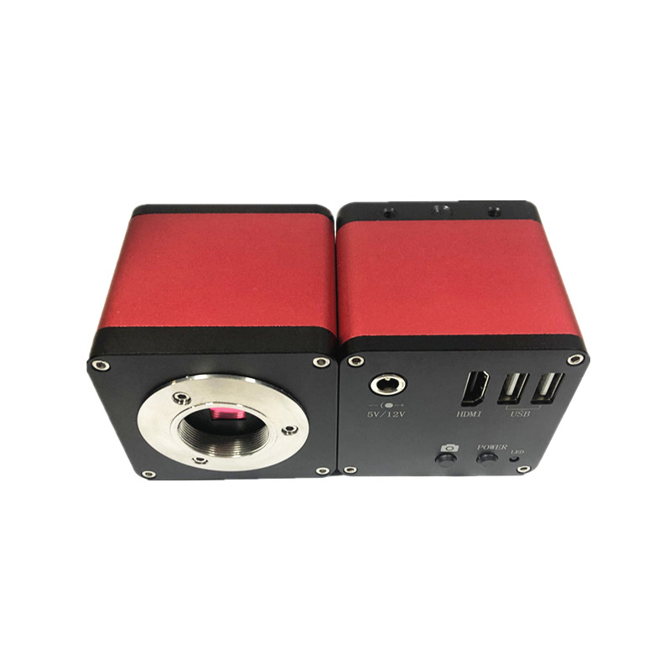

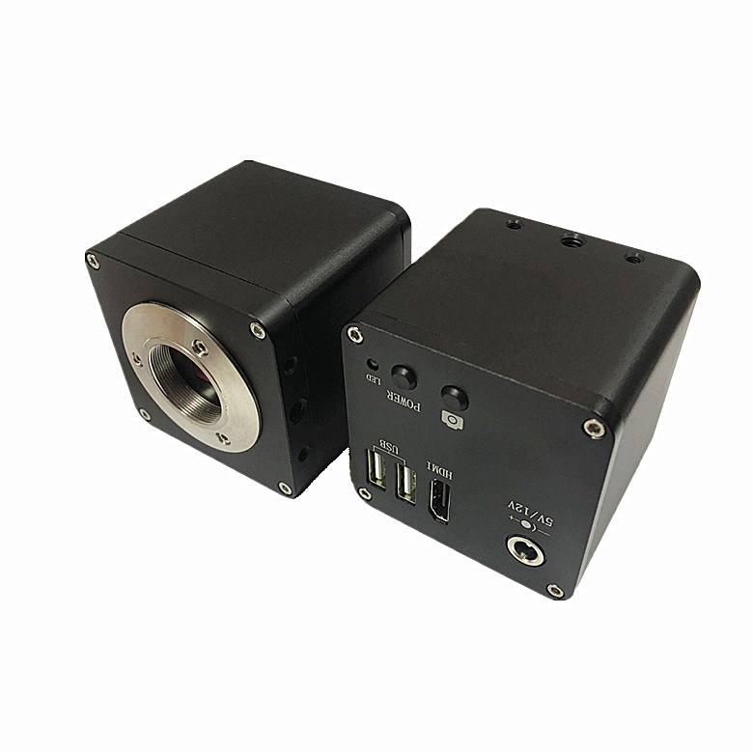
Sensor | 8MP ，1/2.8" SONY CMOS
Resolution | 3840H*2160V
Bit | 12bit
Pixel(μm) | 1.45μm*1.45μm
FPS | 30fps@3840*2160
Sharpness | Above 1500TV line
Scan mode | Progressive scan
Shutter Type | Electronic shutter
Dynamic Range | >90dB
SNR | 55dB
Sensitivity | 2.0 V/lux-sec (550nm)
Exposure Mode | Manual / Auto
White Balance | Manual / Auto
Lens Mount | C/CS
Interface | HDMI Output, 2*USB2.0
UI Operation | With USB Mouse
Image Capture | U-disk memory
Measure | Line. Rect. Circle. Angle. H-line. V-line. Point-line. Parallel-line. Concentric-circles. Circles-distance. Multilateralism. Line-circle. Line-angle. Curve. Point-circle
HDMI Resolution | 1920*1080 60Hz（ Default ）
Operating System | Linux
Power Supply | DC 5V/2A or 12V/1A Adaptor
Size | 63*63*63mm
Menu Function | 1, Two USB 2.0 ports （ One USB mouse, one U-disk memory ）  2, Save the image to usb drive ， view pictures on usb drive or video  3.Cross: 1-12 cross group， Color options ，and line is adjustable in size  4. Scale Ruler ： The number of pixels in each interval can be adjusted arbitrarily  5. Measurement functions ： The distance between two points, rectangle, circle, Angle, etc

